WORKING WITH THE DATASET

|  |  |
| --- | --- |
| Date | 31 October 2022 |
| Team ID | PNT2022TMID08105 |
| Project Name | ANALYTICS FOR HOSPITALS’ HEALTH-CARE DATA |
| Team Member Name | DHASARADHA MAHARAJA.M |

UNDERSTANDING THE DATASET:

DATASET LINK:

https://drive.google.com/drive/folders/1qozDgfVw04hGS8Di_SFhUNdUKUdjkhrT?usp=sharing

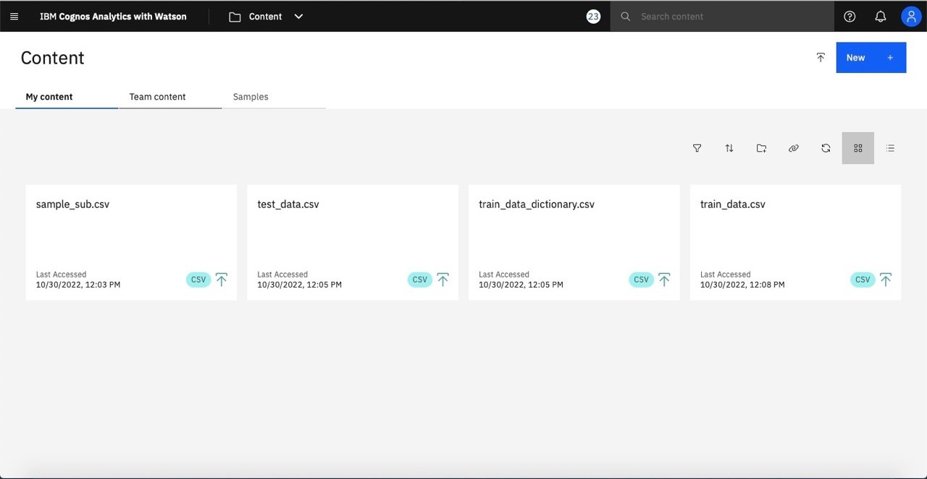

LOADING THE DATASET:

EXPLORATION OF DATA:

